For Mountain Land Physical Therapy:

Your Name
Official MLPT Title
Mountain Land Physical Therapy <<LOCATION>>
(801) 942-3311 Mobile: (801) 999-9999

"We are a leading healthcare provider committed to living our Core Values and inspiring life's most meaningful endeavors."

For Mobile apps:

Your Name
Official MLR Title
Mountain Land Rehabilitation

For Western Rehabilitation Health Network:

Your Name
Official WRHN Title
Western Rehabilitation Health Network
(801) 942-2729 Mobile: (801) 999-9999
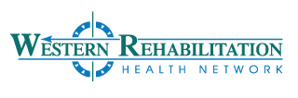

For Precision Credentialing Services:

Your Name
Official Precision Title
Precision Credentialing Services
(801) 942-5625 Mobile: (801) 999-9999

